The following notes are important for running /deploying new server :

1. “ojdbc5.jar” need to be added to project libraries and classpath

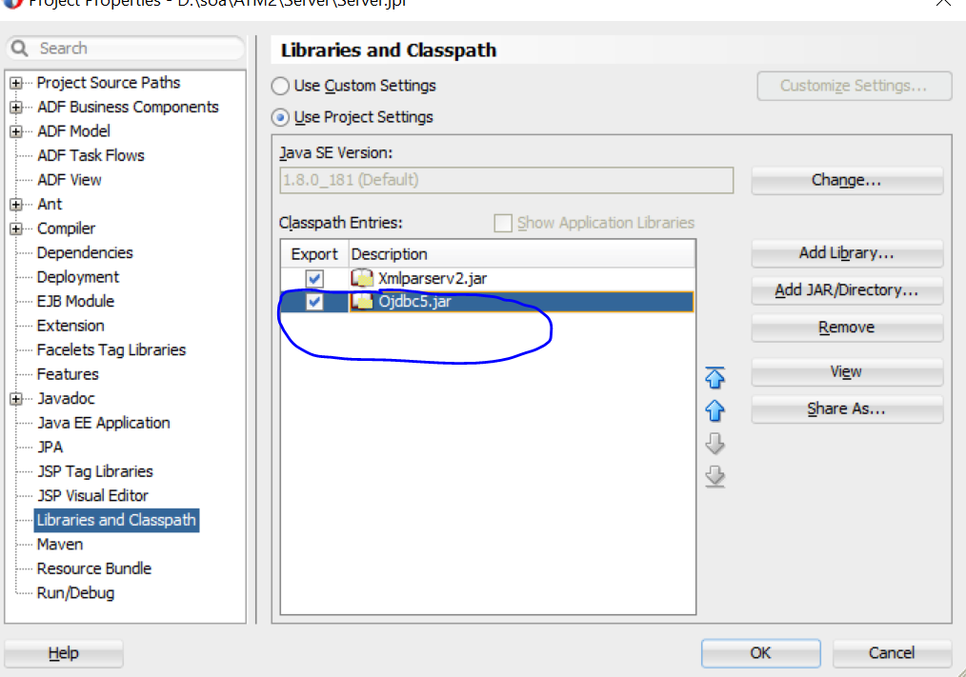

1. NO Jar file is attached since parameters need to be replaced with new values -> existing values are used only for testing ,

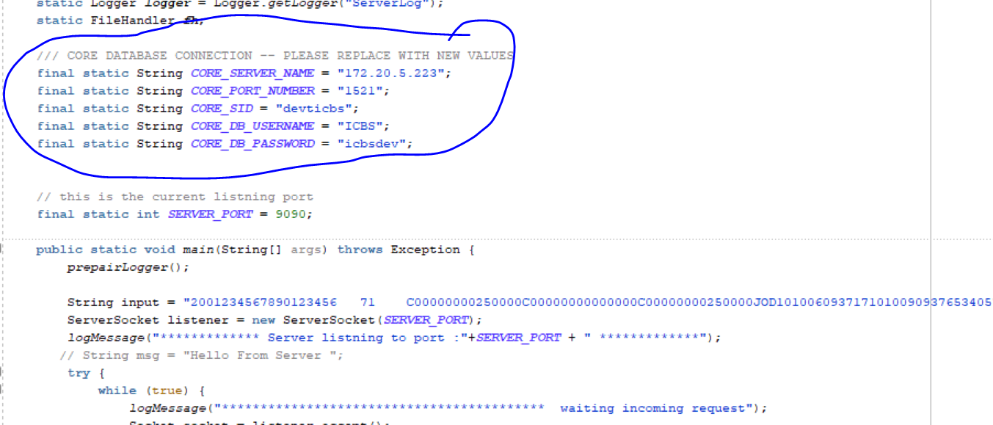

Those values will be used to connect to core DB , please be sure to replace them with new ones ;

1. Nothing is changed on the client , so same old client can be used .